Adobe Experience Platform

Data Pipeline

# Download and Install Azure Storage Explorer

1. Download Azure Storage Explorer by [Microsoft from this link](https://azure.microsoft.com/en-us/blog/microsoft-azure-data-lake-storage-adls-in-storage-explorer-public-preview/)
2. Accept the **End user License Agreement**.

1. In **Select Resource**, select ADLS Gen 2 Container or directory.

1. Select Shared access signature URL (SAS) and click Next

1. Enter the Display name as Data Landing Zone.

1. Leaving this window open, Go to Adobe Experience Platform à **Sources** à **Catalog**. In the Cloud Storage connectors, In the **Data Landing Zone** card, click … and click **View Credentials**.

1. A list of credentials will be displayed. Copy **SASUri** and paste it in the Azure Storage Explorer’s **Blob container or directory SAS URL**.

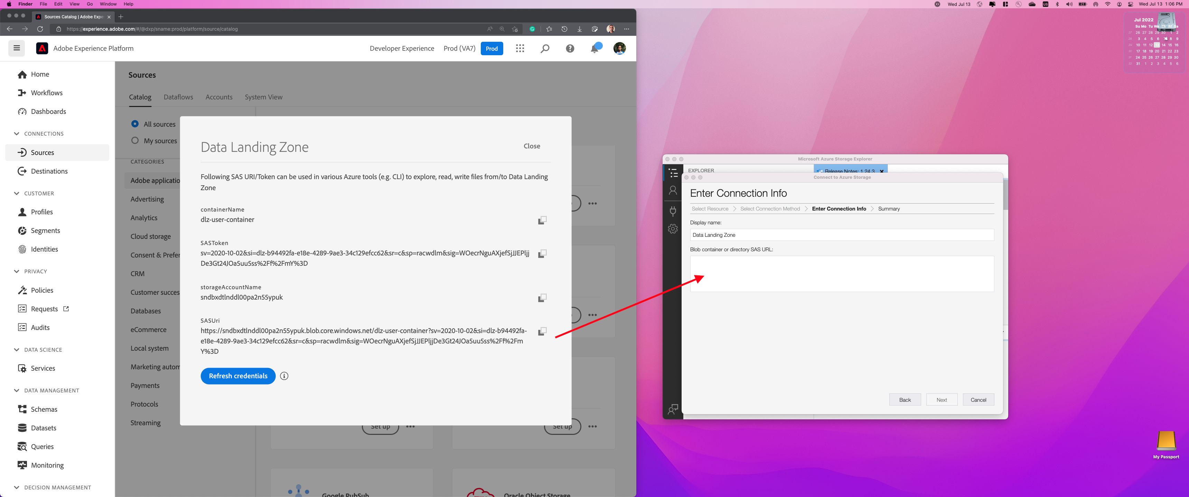

1. Click **Next**

1. Click **Connect**

1. Connection will be successful.

1. You can upload / preview / download the source data from here